**ASSISGNMENT 4**

**Courier Management System**

**TASK 1**

1.DATABASE DESIGN

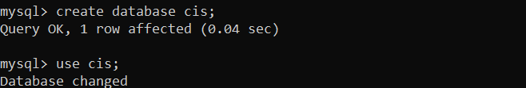

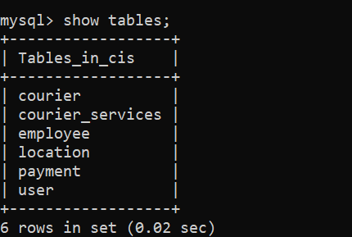

CREATE TABLE user(

userid INT PRIMARY KEY,

name VARCHAR(255),

email VARCHAR(255) UNIQUE,

password VARCHAR(255),

contact VARCHAR(20),

address TEXT);

INSERT INTO USER VALUES

(1,'Gowtham','gowtham@gmail.com','gg123','1234567890','ABC street'),

(2,'John','john@gmail.com','john','1234567980','BBB street'),

(3,'Nithya','nithya@gmail.com','nithya','1234568790','CCC street'),

(4,'Rohan','rohan@gmail.com','rohan','1234567890','DAC street'),

(5,'Vikram','vikram@gmail.com','vikram','1234567890','ECR street'),

(6,'Gokul','gokul@gmail.com','gokul','1234567890','MNC street'),

(7,'Hema','hemaa@gmail.com','hema','1234567980','ORC street'),

(8,'Swetha','swetha@gmail.com','swetha','1234568790','CAB street'),

(9,'Mani','mani@gmail.com','mani','1234567890','LOC street'),

(10,'Paul','paul@gmail.com','paul','1234567890','GRC street');

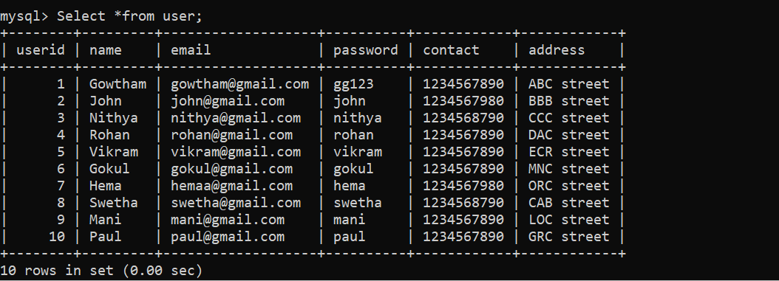

CREATE TABLE courier(

Courier_id INT PRIMARY KEY,

Sender_name VARCHAR(255),

sender_address TEXT,

receiver_name VARCHAR(255),

receiver_address TEXT,

weight DECIMAL(5,2),

status VARCHAR(50),

tracking_no VARCHAR(20) UNIQUE,

delivery_date DATE);

INSERT INTO COURIER VALUES

(101,'rohan','dac street','Gokul','mnc street',565,'undelivered','1234','2023-12-25'),

(102,'John','bbb street','nithya','ccc street',500,'delivered','4321','2023-12-01'),

(103,'paul','grc street','John','bbb street',200,'cancelled','5555','2023-11-19'),

(104,'Gokul','mnc street','swetha','cab street',750,'undelivered','5424','2023-12-25'),

('105', 'vikram', 'ecr street', 'mani', 'loc street', '900.00', 'delivered', '4657', '2023-10-05'),

('106', 'john', 'bbb street', 'Gokul', 'mnc street', '380.00', 'delivered', '9008', '2023-12-30'),

(107,'hema','orc street','Gowtham','abc street',565,'undelivered','12345','2023-12-01'),

(108,'paul','grc street','rohan','dac street',500,'delivered','43216','2023-12-05'),

(109,'vikram','ecr street','John','bbb street',200,'cancelled','55551','2023-11-10'),

(110,'Gowtham','abc street','nithya','ccc street',750,'undelivered','54324','2023-12-21');

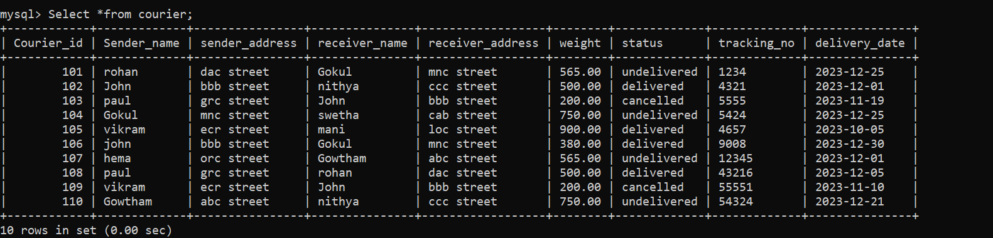

CREATE TABLE Courier_services(

Service_id INT PRIMARY KEY,

Service_name VARCHAR(100),

cost DECIMAL(8,2));

INSERT INTO COURIER_SERVICES VALUES

(201,' ecomexpress ',1800),

(202,'blue_dart',2000),

(203,'fedex',1500),

(204, 'fastexpress ',3000),

(205, 'abcexpress',1560);

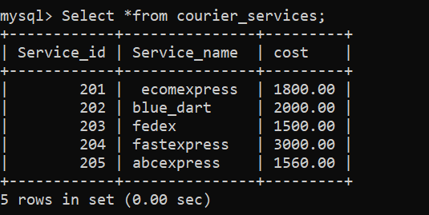

CREATE TABLE employee(

Emp_id INT PRIMARY KEY,

Name VARCHAR(255),

Email VARCHAR(255) UNIQUE,

Contact VARCHAR(20),

Role VARCHAR(50),

Salary DECIMAL(10,2));

INSERT INTO EMPLOYEE VALUES

(301,'Doel','doel@gmail','1234557890','delivery',30000),

(302,'Michel','michel@gmail','1243557890','delivery',25000),

(303,'Tharun','tharun@gmail','1234557790','supervisor',40000),

(304,'Hari','hari@gmail','9234557890','delivery',25000),

(305,'Sathya','sathya@gmail','1234555890','Manager',95000),

(306,'Joel','joel@gmail','1234557899','delivery',30000),

(307,'Mike','mike@gmail','1247557890','delivery',25000),

(308,'Tharshan','tharshan@gmail','1234557790','supervisor',45000),

(309,'Harish','harish@gmail','9234597890','delivery',25000),

(310,'Sathyan','sathyan@gmail','9834555890','Manager',95000);

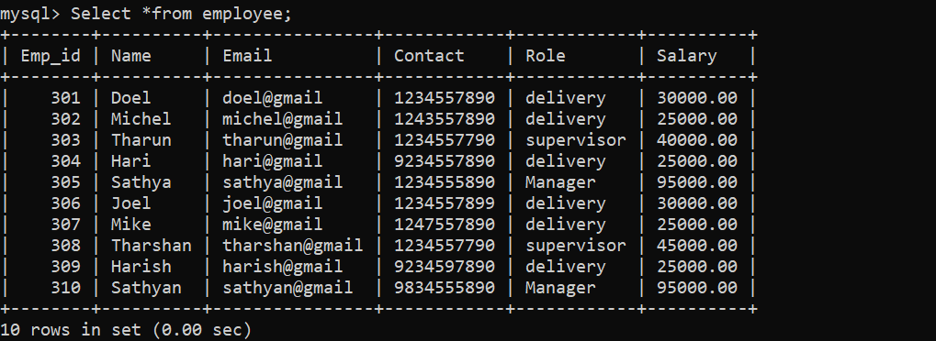

CREATE TABLE location(

Location_id INT PRIMARY KEY,

Location_name VARCHAR(100),

address TEXT);

INSERT INTO LOCATION VALUES

(401,'A place','abc street'),

(402,'B place','bbb street'),

(403,'C place','ccc street'),

(404,'D place','dac street'),

(405,'E place','ecr street'),

(406,'F place','mnc street'),

(407,'G place','orc street'),

(408,'H place','cab street'),

(409,'I place','loc street'),

(410,'J place','grc street');

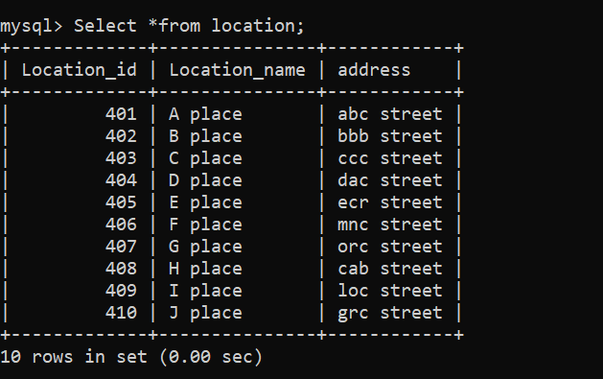

CREATE TABLE payment(

Payment_id INT PRIMARY KEY,

Courier_id INT,

Location_id INT,

amount DECIMAL(10,2),

payment_date DATE,

FOREIGN KEY(courier_id) REFERENCES courier(courier_id),

FOREIGN KEY(location_id) REFERENCES location(location_id));

INSERT INTO PAYMENT VALUES

(501,101,401,5650,'2023-12-28'),

(502,102,404,5000,'2023-10-01'),

(503,103,402,2000,'2023-10-19'),

(504,104,403,7500,'2023-12-15'),

(505, 106, 405, 3800,'2023-12-03'),

(506,105,406,5750,'2023-12-01'),

(507,107,407,5500,'2023-12-11'),

(508,108,408,2100,'2023-11-29'),

(509,109,409,6500,'2023-12-05'),

(510, 110, 410, 3900,'2023-12-03');

INSERT INTO payment (`paymentid`, `courierid`, `locationid`, `amount`, `paymentdate`) VALUES ('505', '106', '401', '3800.00', '2023-12-30');

UPDATE payment SET `courierid` = '104', `locationid` = '403', `amount` = '7500.00', `paymentdate` = '2023-12-25' WHERE (`paymentid` = '503');

UPDATE payment SET `courierid` = '105', `locationid` = '405', `amount` = '9000.00', `paymentdate` = '2023-12-05' WHERE (`paymentid` = '504');

ALTER TABLE PAYMENT ADD COLUMN payment_time time;

UPDATE `payment` SET `payment_time` = '09:00:00' WHERE (`payment_id` = '501');

UPDATE `payment` SET `payment_time` = '10:00:00' WHERE (`payment_id` = '502');

UPDATE `payment` SET `payment_time` = '09:30:00' WHERE (`payment_id` = '503');

UPDATE `payment` SET `payment_time` = '11:00:00' WHERE (`payment_id` = '504');

UPDATE `payment` SET `payment_time` = '09:00:00' WHERE (`payment_id` = '505'),

UPDATE `payment` SET `payment_time` = '03:00:00' WHERE (`payment_id` = '506');

UPDATE `payment` SET `payment_time` = '10:50:00' WHERE (`payment_id` = '507');

UPDATE `payment` SET `payment_time` = '05:30:00' WHERE (`payment_id` = '508');

UPDATE `payment` SET `payment_time` = '01:30:00' WHERE (`payment_id` = '509');

UPDATE `payment` SET `payment_time` = '08:00:00' WHERE (`payment_id` = '510');

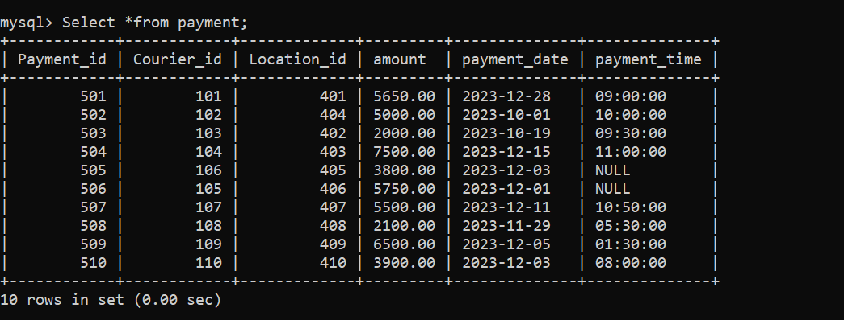

TASK 2

1. List all customers

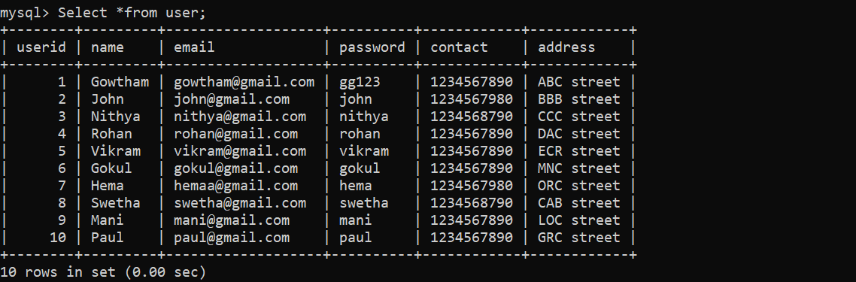

2. List all orders for a specific customer

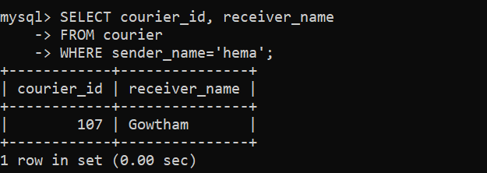

3. List all couriers

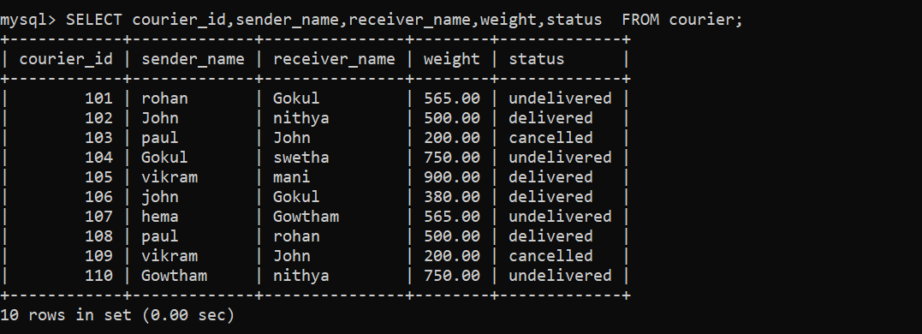

4. List all packages for a specific order

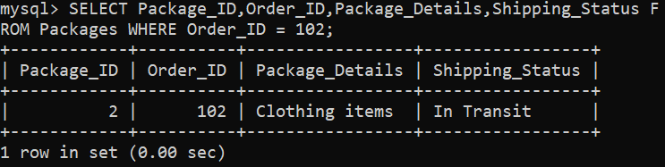

5. List all deliveries for a specific courier

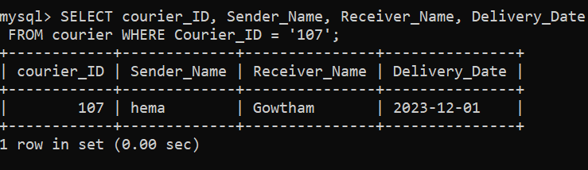

6. List all undelivered packages

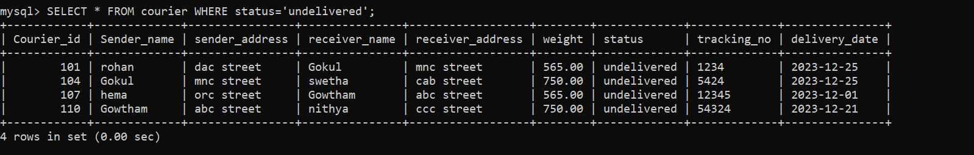

7. List all packages that are scheduled for delivery today



8. List all packages with a specific status

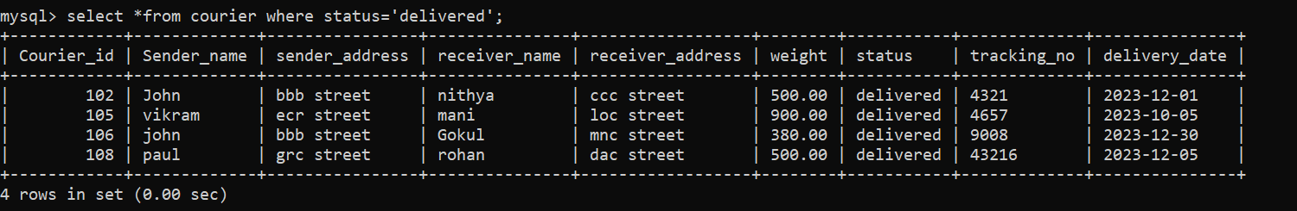

9. Calculate the total number of packages for each courier.

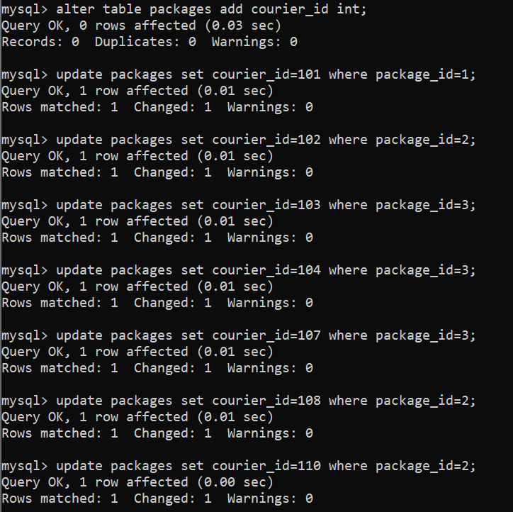

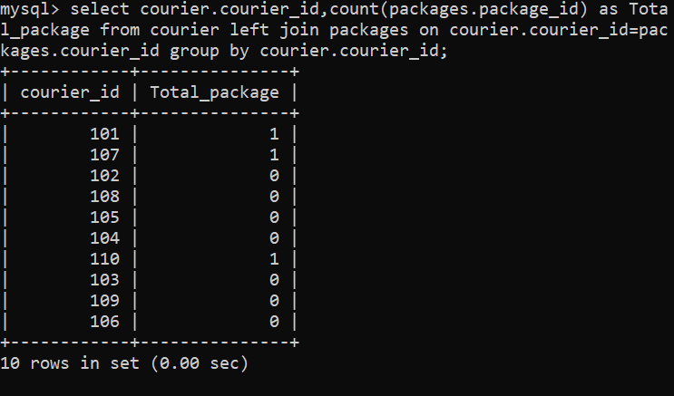

10. Find the average delivery time for each courier

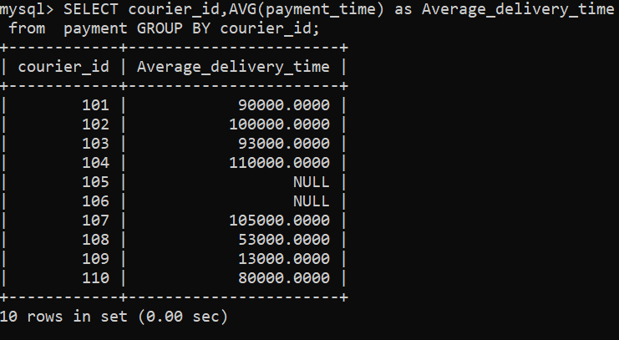

11. List all packages with a specific weight range

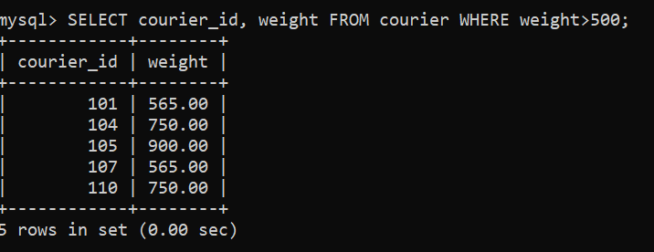

12. Retrieve employees whose names contain 'John'

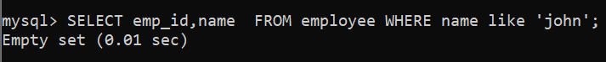

13. Retrieve all courier records with payments greater than $50.

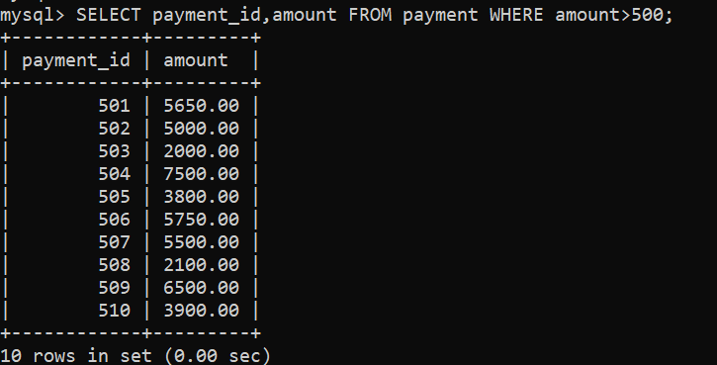

**Task 3**

14. Find the total number of couriers handled by each employee.

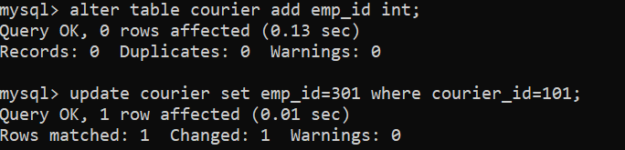

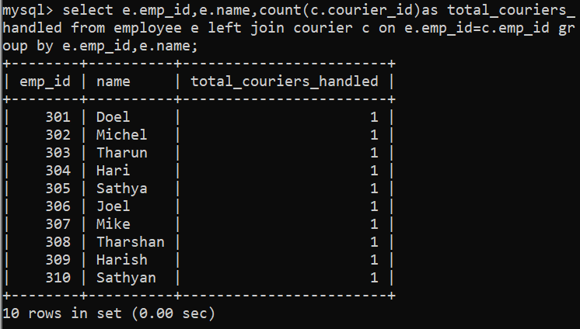

15. Calculate the total revenue generated by each location

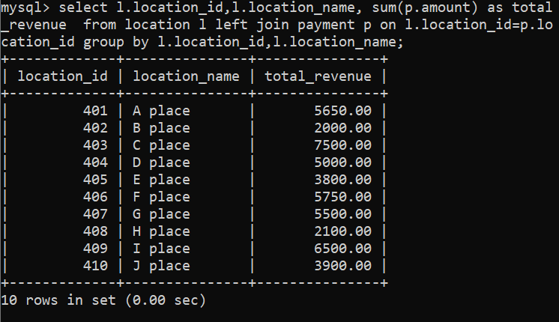

16. Find the total number of couriers delivered to each location.

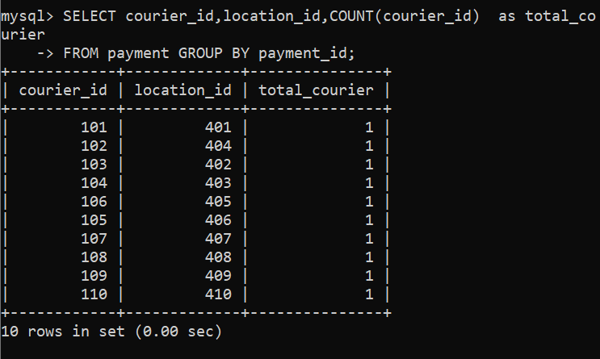

17. Find the courier with the highest average delivery time

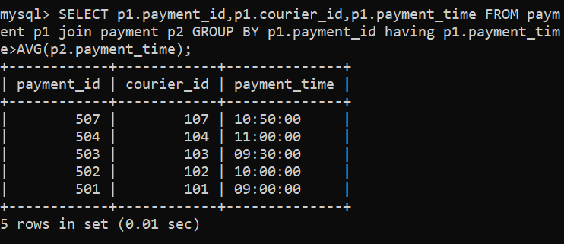

18. Find Locations with Total Payments Less Than a Certain Amount

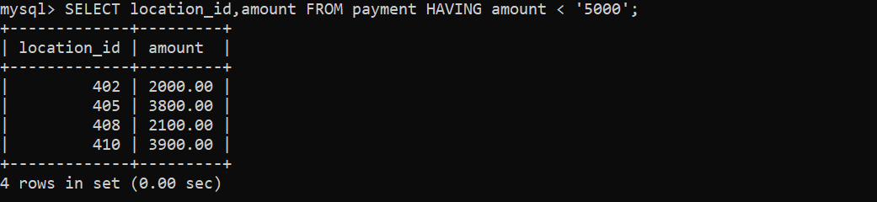

19. Calculate Total Payments per Location

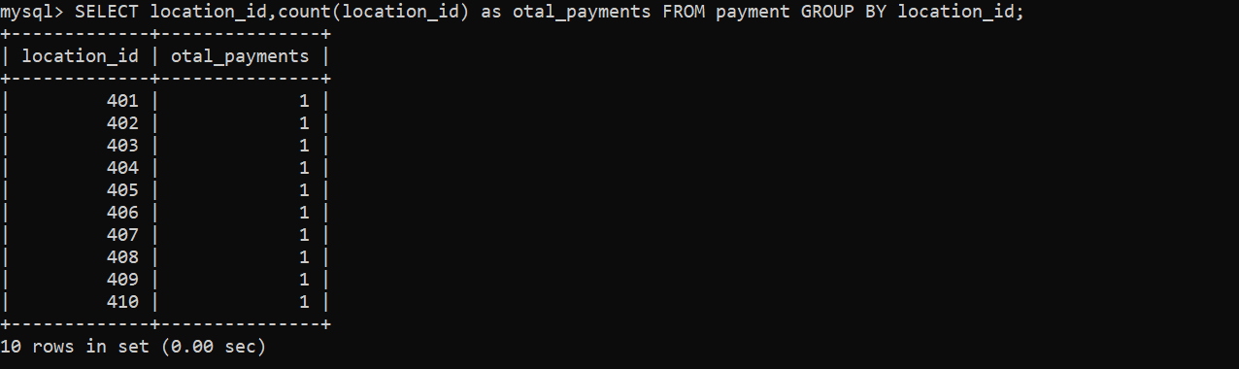

20. Retrieve couriers who have received payments totaling more than $1000 in a specific location (LocationID = X)

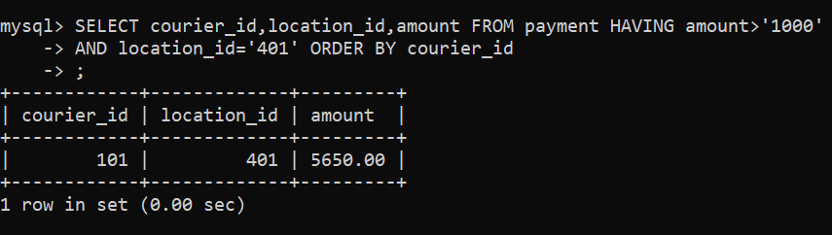

21. Retrieve couriers who have received payments totaling more than $1000 after a certain date (PaymentDate > 'YYYY-MM-DD')

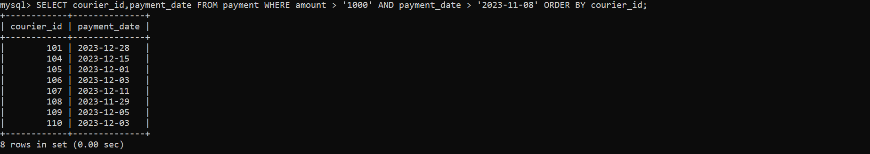

22. Retrieve locations where the total amount received is more than $5000 before a certain date (PaymentDate > 'YYYY-MM-DD')

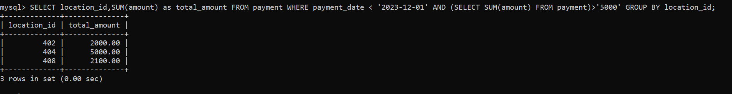

Task 4

23. Retrieve Payments with Courier Information

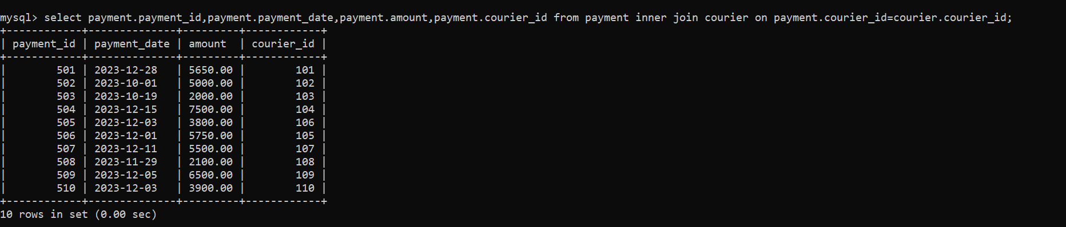

24. Retrieve Payments with Location Information

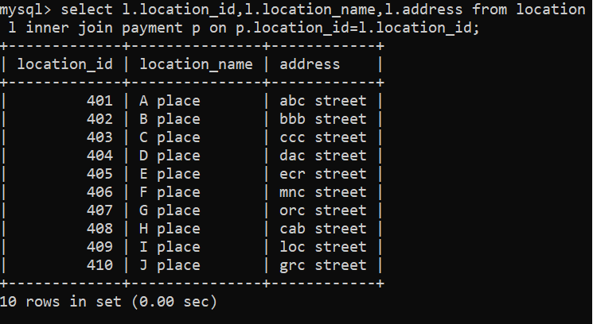

25. Retrieve Payments with Courier and Location Information

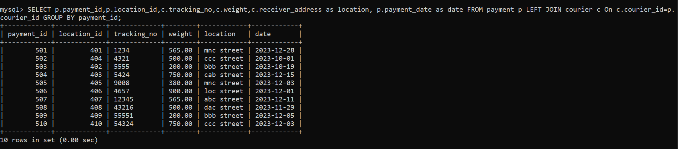

26. List all payments with courier details

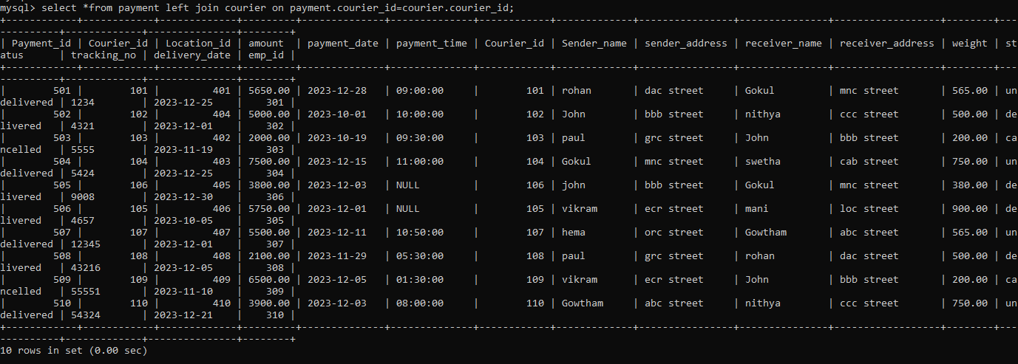

27. Total payments received for each courier

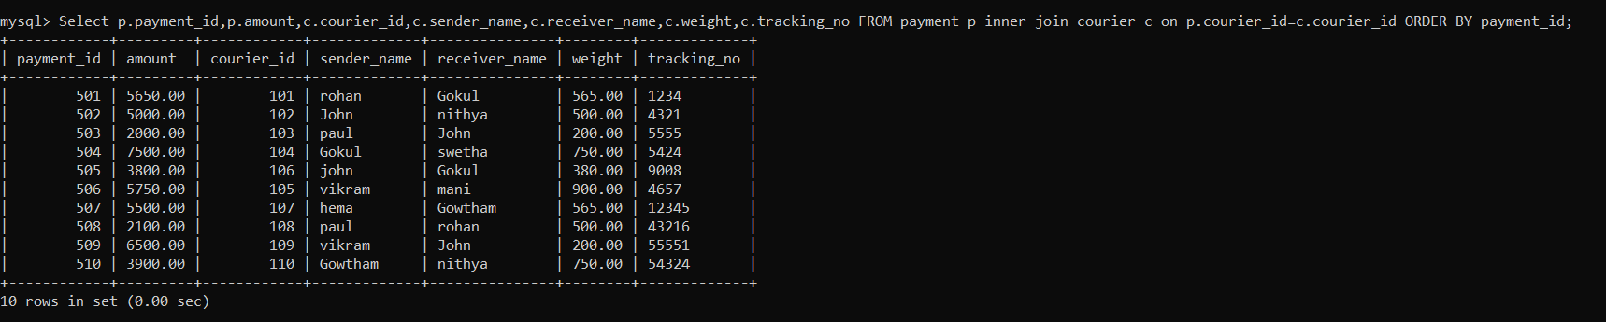

28. List payments made on a specific date

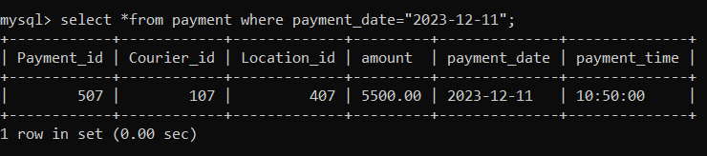

29. Get Courier Information for Each Payment

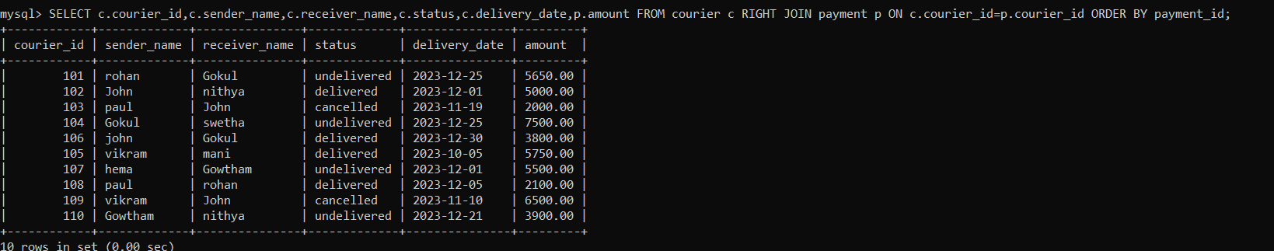

30. Get Payment Details with Location

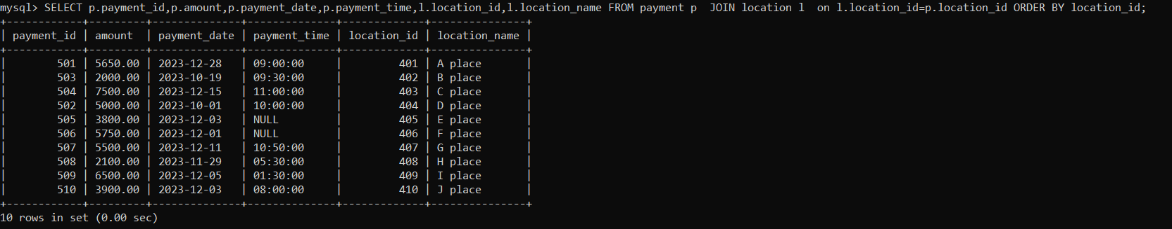

31. Calculating Total Payments for Each Courier

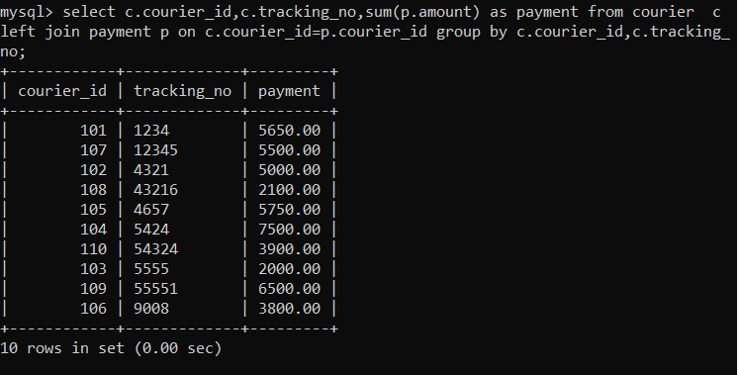

32. List Payments Within a Date Range

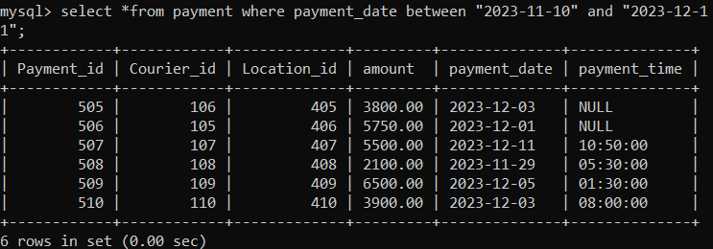

33. Retrieve a list of all users and their corresponding courier records

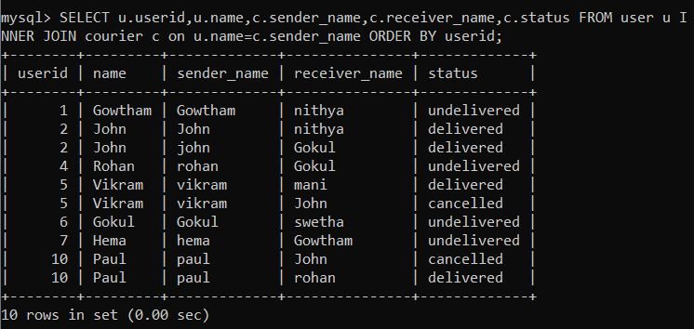

34. Retrieve a list of all couriers and their corresponding services

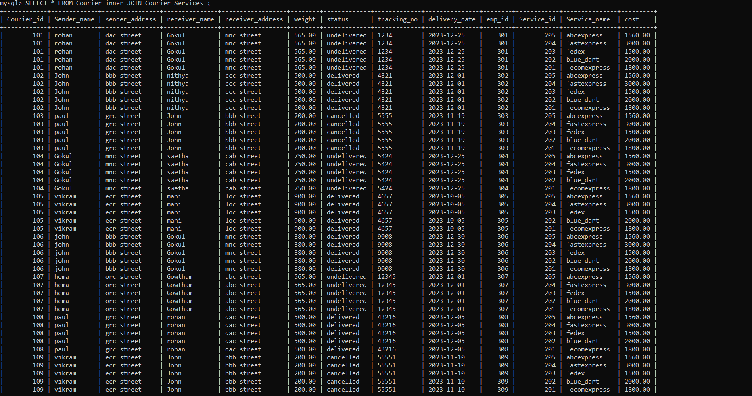

35. Retrieve a list of all employees and their corresponding payments

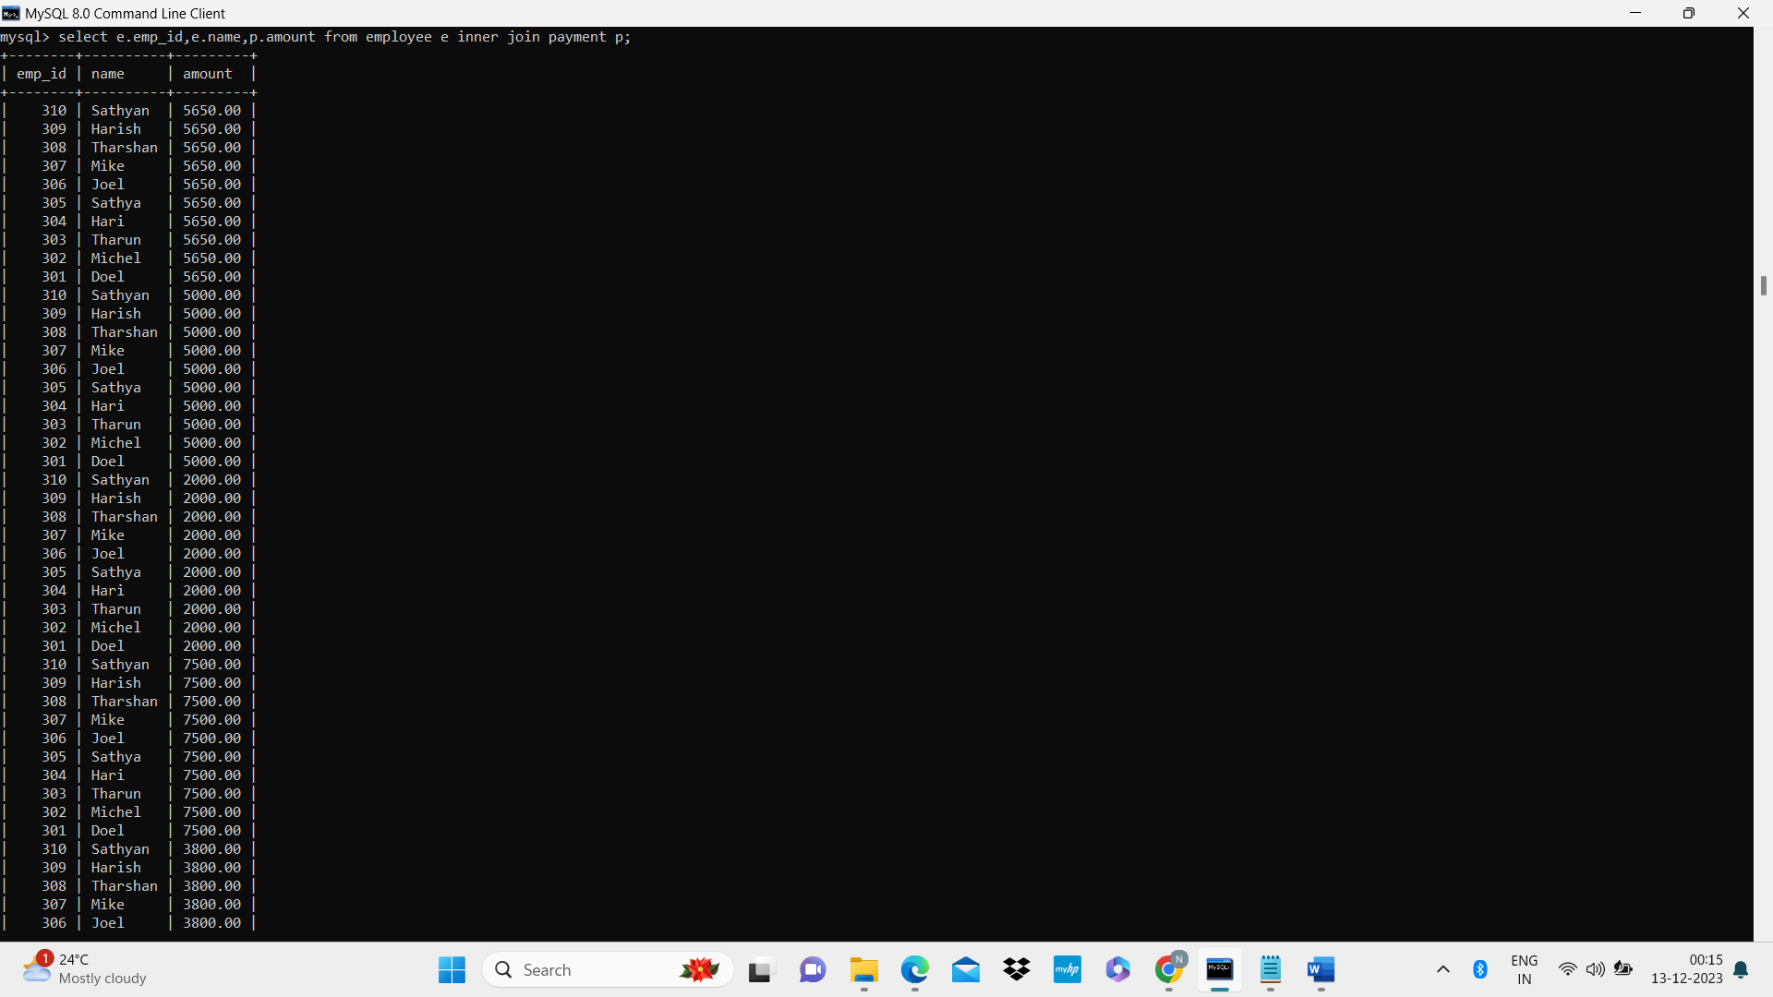

36. List all users and all courier services, showing all possible combinations.

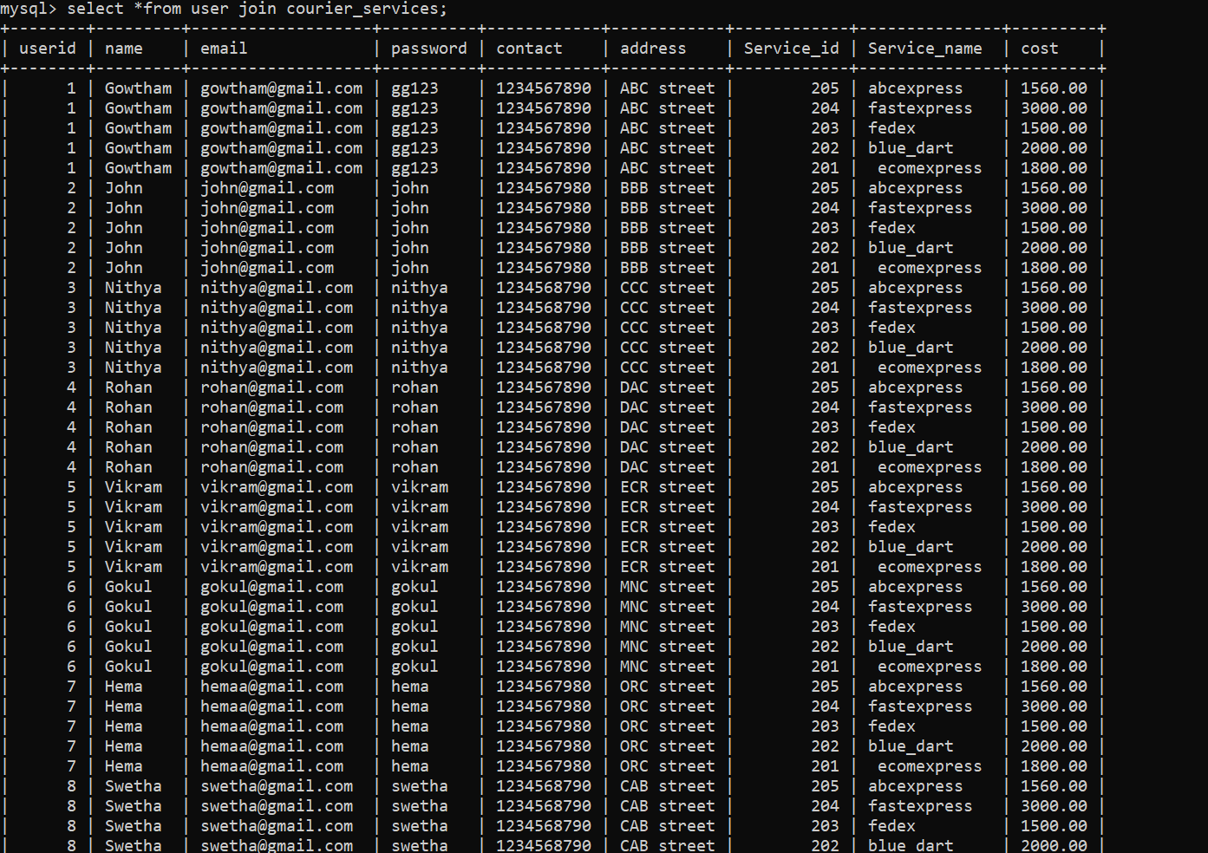

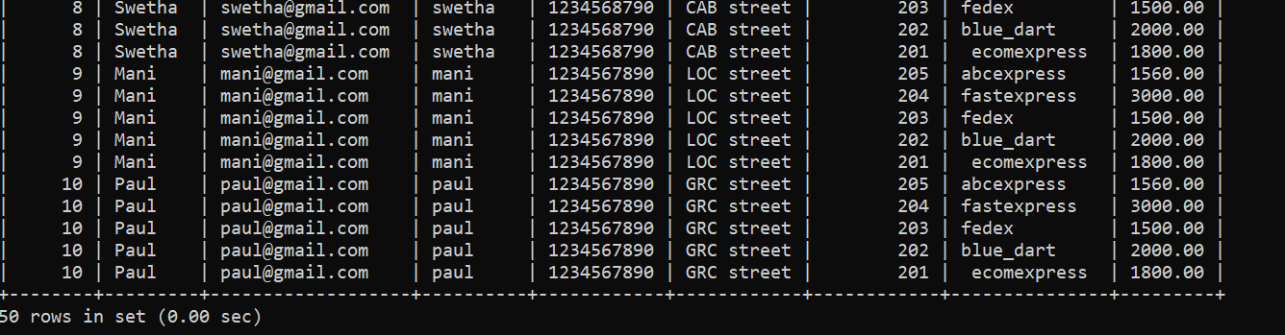

37. List all employees and all locations, showing all possible combinations

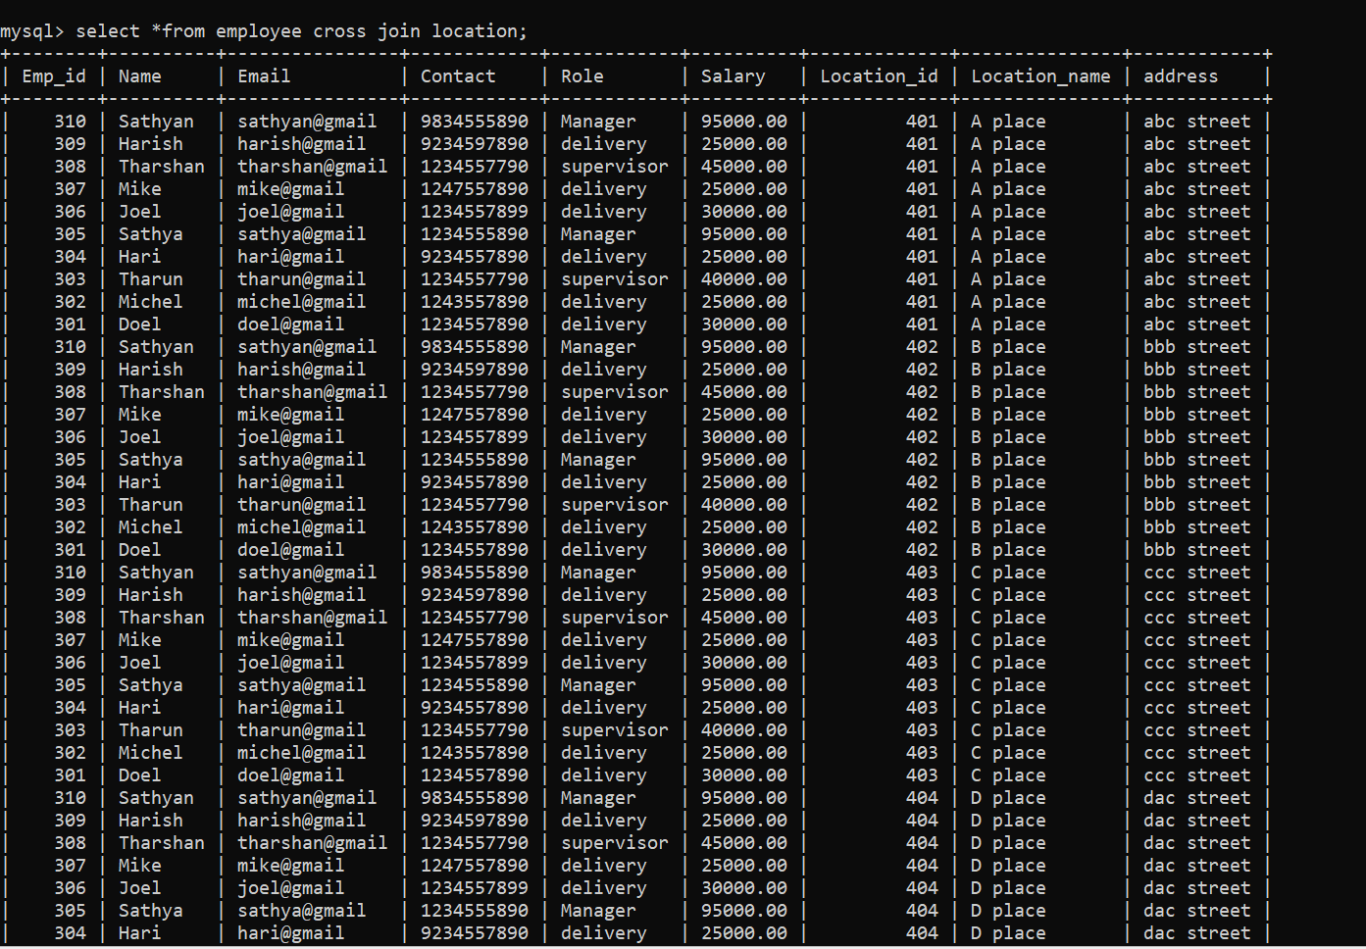

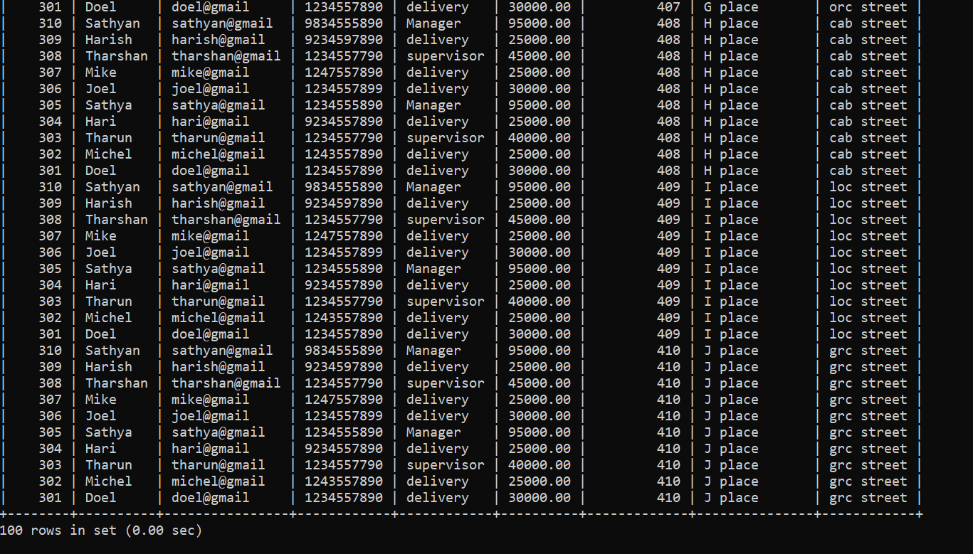

38. Retrieve a list of couriers and their corresponding sender information (if available)

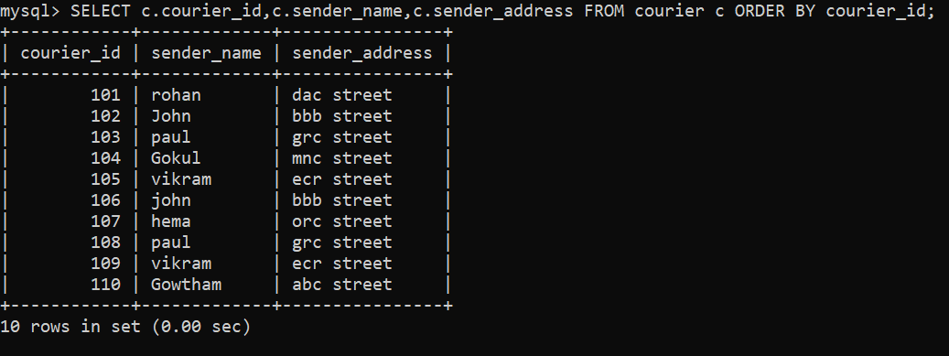

39. Retrieve a list of couriers and their corresponding receiver information (if available)

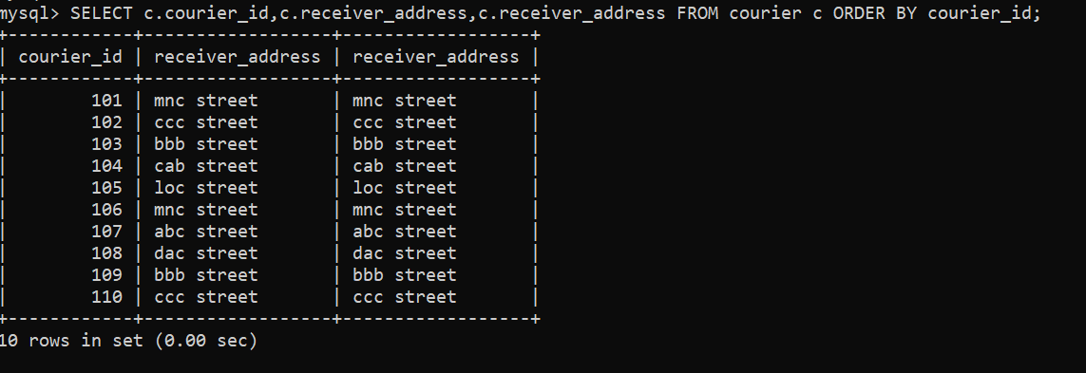

40. Retrieve a list of couriers along with the courier service details (if available)



41. Retrieve a list of employees and the number of couriers assigned to each employee

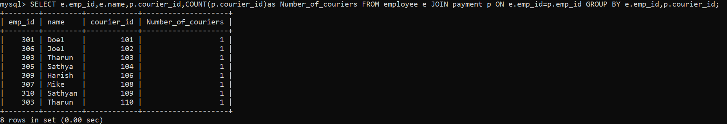

42. Retrieve a list of locations and the total payment amount received at each location

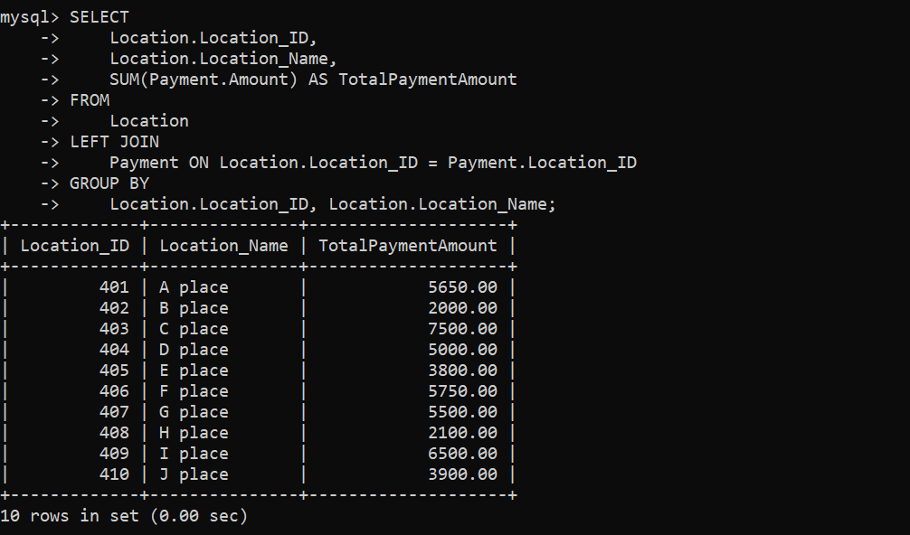

43. Retrieve all couriers sent by the same sender (based on SenderName).

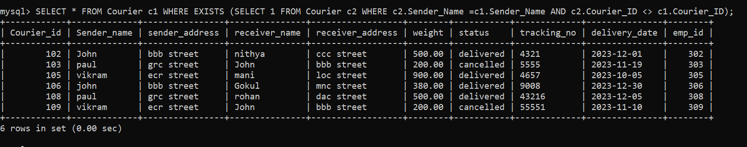

44. List all employees who share the same role.

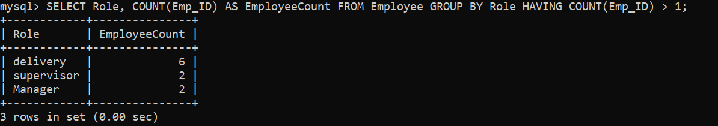

45. Retrieve all payments made for couriers sent from the same location.

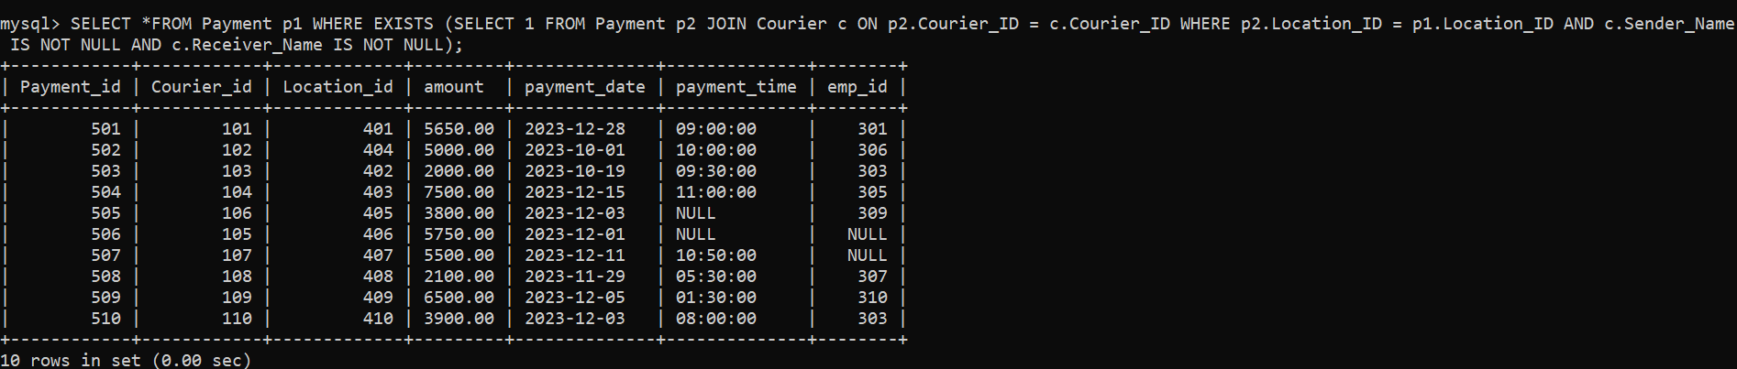

46. Retrieve all couriers sent from the same location (based on SenderAddress).

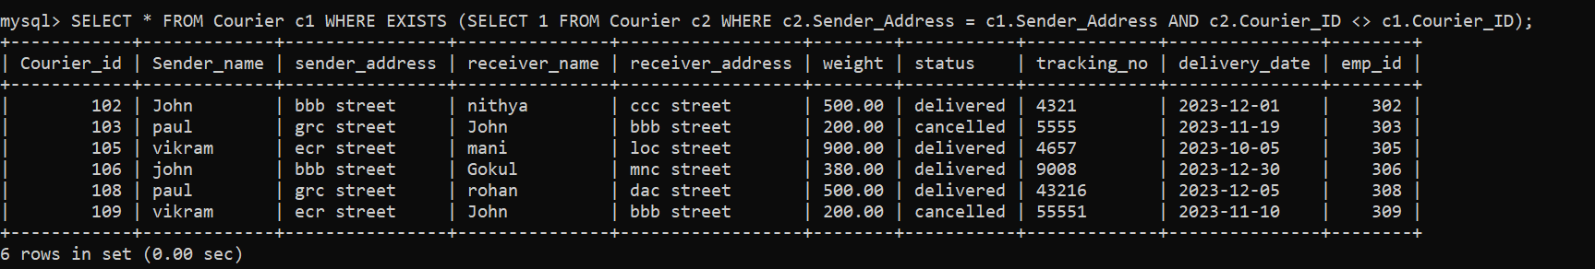

47. List employees and the number of couriers they have delivered

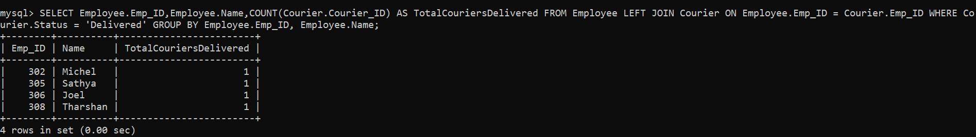

48. Find couriers that were paid an amount greater than the cost of their respective courier services Scope: Inner Queries, Non Equi Joins, Equi joins,Exist,Any,All

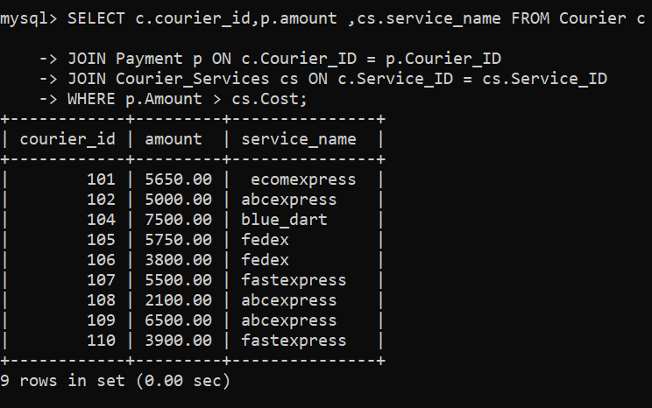

49. Find couriers that have a weight greater than the average weight of all couriers

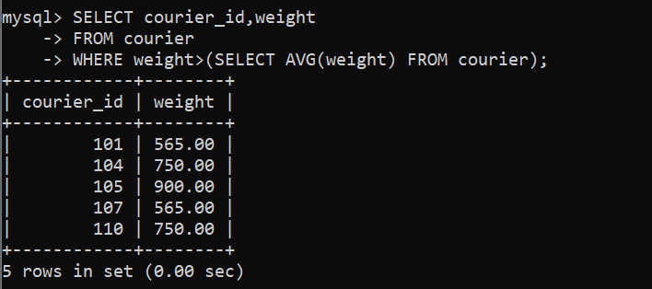

50. Find the names of all employees who have a salary greater than the average salary:

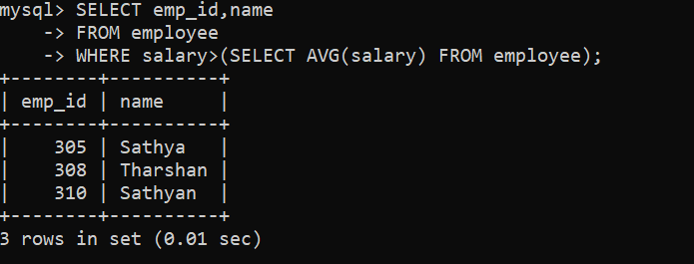

51. Find the total cost of all courier services where the cost is less than the maximum cost

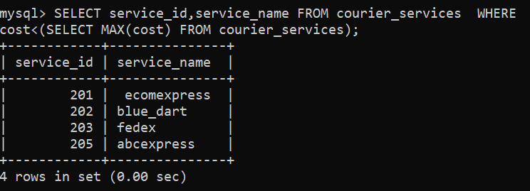

52. Find all couriers that have been paid for

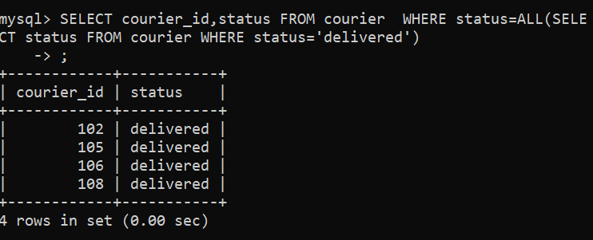

53. Find the locations where the maximum payment amount was made

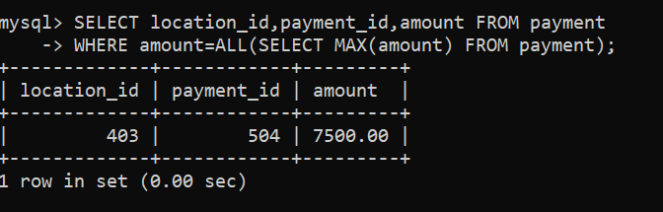

54. Find all couriers whose weight is greater than the weight of all couriers sent by a specific sender (e.g., 'SenderName'):

